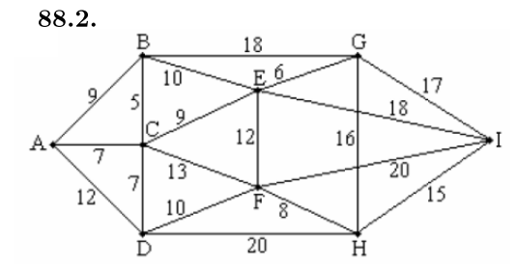
RAMOS

12 (A, D)
12 (E, F)
13 (C, F)
15 (H, I)
5 (B, C)
6 (E, G)
7 (A, C)
7 (C, D)
8 (F, H)
9 (C, E)
9 (A, B)
10 (B, E)
10 (D, F)

It | (vi,vj) | Si | Sj | T | S1 | S2 | S3 | S4 | S5 | S6 | S7 | S8 | S9 | S10 | S11 | Nr
 |  |  |  |  | A | B | C | D | E | F | G | H | I
1 | (B, C) | 2 | 3 | (B, C) | A | B, C | D | E | F | G | H | I |  |  |  | 1
2 | (E, G) | 4 | 6 | (E, G) | A | B, C | D | E,G | F | H | I |  |  |  |  | 2
3 | (A, C) | 1 | 2 | (A, C) | A, B, C | D | E, G | F | H | I |  |  |  |  |  | 3
4 | (C, D) | 1 | 2 | (C, D) | A, B, C, D | E, G | F | H | I |  |  |  |  |  |  | 4
5 | (F, H) | 3 | 4 | (F, H) | A, B, C, D | E, G | F, H | I |  |  |  |  |  |  |  | 5
6 | (C, E) | 2 | 1 | (C, E) | A, B, C, D, E, G | F, H | I |  |  |  |  |  |  |  |  | 6
7 | (A, B) | 1 | 1
8 | (B, E) | 1 | 1
9 | (D, F) | 1 | 2 | (D, F) | A, E, G, B, C, D, F, H | I |  |  |  |  |  |  |  |  |  | 7
10 | (A,D) | 1 | 1
11 | (E, F) | 1 | 1
12 | (C, F) | 1 | 1
13 | (H,I) | 1 | 2 | (H, I) | A, E, G, B, C, D, F, H, I |  |  |  |  |  |  |  |  |  |  | 8

A árvore é T={(B, C), (E, G), (A, C), (C, D), (F, H), (C, E), (D, F), (H, I)} e o custo é 5+6+7+7+8+9+10+15=67

